Theoretical context:
The main goal of this project is to explore and characterise the interplay between oral and written output/response modalities. Research on language production and particularly on the influence of phonology and orthography in L1 language production has indicated an interplay between the oral (speaking) and written (handwriting) output modalities.
Evidence supports the activation of both orthographic representations during oral production (Rastle et al., 2011) and phonological representations during written production (Bonin et al., 2001). Rastle and colleagues (2011) investigated whether orthography influences word processing and production through novel word learning, manipulating spelling-sound consistency. In line with previous findings on speech perception, they showed an orthographic effect on auditory lexical decision. They also demonstrate that orthography is co-activated and involved in oral language production tasks where spelling-sound consistency is perfectly manipulated and orthographic processing is not required. Regarding written picture naming, Bonin and colleagues (2001) tested the possibility that phonology constrains the selection of orthographic representations, again through manipulation of sound-spelling inconsistency. They identified that word-initial inconsistencies in written picture naming, and word-initial as well as word-final inconsistencies in auditory stimulus presentation cause longer written latencies. This supports the claim that phonology indeed constrains activation of orthographic representations and is thus co-activated during writing.
A means to explore the interplay between oral and written output modalities is through the switching paradigm. Research tapping on task execution and task inhibition indicated switching costs as well as an asymmetry in modality switch (Philipp & Koch, 2005; Philipp & Koch, 2011; Philipp et al., 2013). More specifically, switching between different response modalities (e.g. oral vs. manual) within the same numerical-judgement task prompted longer response latencies and higher error rates than did modality repetition. Philipp and Koch (2011) also showed an asymmetry (albeit non-systematic) of modality switching, namely larger modality-shift costs for vocal rather than for manual responses, but no asymmetry was found for shift costs between vocal and foot responses, nor between manual and foot responses.
A similar pattern has been found in language switching. Both an effect of condition (language repeat vs. language switch) and an effect of language (L1 vs. L2) was supported. With regard to the latter effect, switching from the second (L2) less dominant language to the first (L1) more dominant one was more cognitively costly than vice versa (Costa & Santesteban, 2004; Filippi et al., 2014; Jevtović et al., 2020). This asymmetry in shift costs between the two languages is interpreted in terms of language inhibition during production. The dominant language (L1) has to be strongly inhibited during L2 production, while the less dominant language (L2) necessitates less inhibition (for being less dominant). Thus, switching to the L1 would mean recovering from a strong inhibition, unlike switching to the L2 that would mean recovering from a light inhibition (Meuter & Allport, 1999; Macizo et al., 2012).
Overall, language and task switching research provide evidence for an asymmetry in switch costs between different languages/tasks. They also point towards the inhibition of one language/task for the successful production of the other. Our goal is to employ the same paradigm as in task switching for modality switching in oral and written language production. More specifically, we support that there is a switch cost that is asymmetrical in switching between different response modalities. However, a major difference between task and modality switching is that, while we cannot perform two different numerical judgement tasks at the same time, speaking and writing are two activities that can be performed simultaneously. For that reason, we do not support the dominance of one modality over the other, but rather we argue for the co-activation of phonological and orthographic representations during oral and written naming and focus on the strength of this co-activation in each task (speak – write). However, literature on language production suggests that phonology is more dominant than orthography in terms of the activation of representations during language production (Luria, 1970; Scinto, 1986; Miceli et al., 1997). This is mainly attributed to our ability to speak in our dominant language chronologically preceding our ability to write. Thus, orthographic representations necessarily build on phonological ones. Nevertheless, there has been research conducted on speech perception that indicates that orthographic representations influence the perception, recognition, and processing of spoken language (Kolinsky et al., 2012; Pattamadilok et al., 2009).
These claims we will attempt to unpack in a response-modality switching experiment in which picture naming will be conducted by switching between written and spoken responses. Taking into consideration the literature on the dominance of phonological over orthographic representations as well as research supporting the importance of both representations for language production (Bonin et al., 2001; Rastle et al., 2011), we expect to observe switch costs between oral and written naming. We also expect these switch costs to be asymmetrical in terms of the co-activation of phonological and orthographic representations when switching between response modalities. In other words, we should observe greater switch costs when switching from spoken to written naming than vice versa. We will also test response modality switch in terms of typing and speaking instead of handwriting and speaking (Wong & Maurer, 2021), taking into consideration the fact that typing is pervasive in replacing handwriting as the preferred way of written communication (Pinet et al., 2016; Pinet et al., 2022).

Objective:
We are interested in the interplay and dynamics of the co-activation of orthographic and phonological representations in language production. More specifically, we will examine whether orthographic and phonological representations are constantly co-activated during word production and whether this co-activation is (a)symmetrical in native speakers of Spanish. To that aim, we will ask participants to switch between response modalities, namely speaking and typing, in a picture naming task.

Main hypotheses:
1. A main effect of condition on reaction times is expected. Namely, response latencies for same-item naming are expected to be overall quicker between repeat trials (same modality: type-type / speak-speak) than between switch trials (same item, different modality).
2. We also expect a main effect of modality on reaction times, whereby response latencies for same-item naming are expected to be overall quicker in the speaking condition than in the typing condition.
3a. A significant interaction is also expected between condition and modality. Namely, if phonology is strongly co-activated when typing and orthography weakly co-activated when speaking (Figure 1), larger switch costs to typing than to speaking (for the same item) are expected (Figure 2).
3b. If orthography is also strongly co-activated when speaking, we do not expect larger switch costs to speaking than those to typing.
4. Response durations are expected to be shorter in repeat trials. In filler trials where participants should name different items but within the same modality, durations should not be much longer than in repeat trials. Durations in switch trials should be the longest. This pattern is expected to be the same both for typing and for speaking.

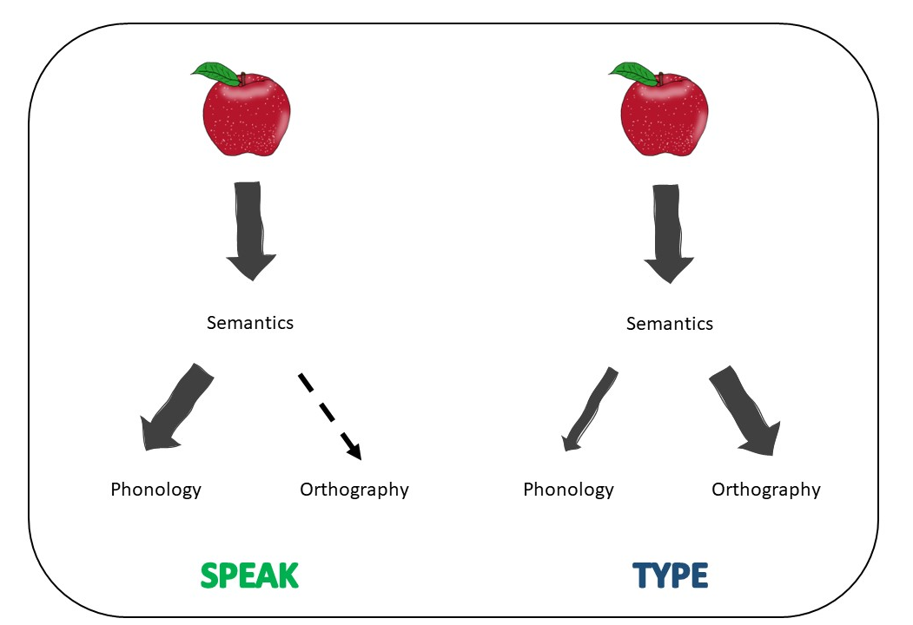
Figure 1. Visualisation of the co-activation of phonology and orthography during speaking and writing. Phonology is strongly co-activated when writing, while orthography is weakly co-activated when speaking.

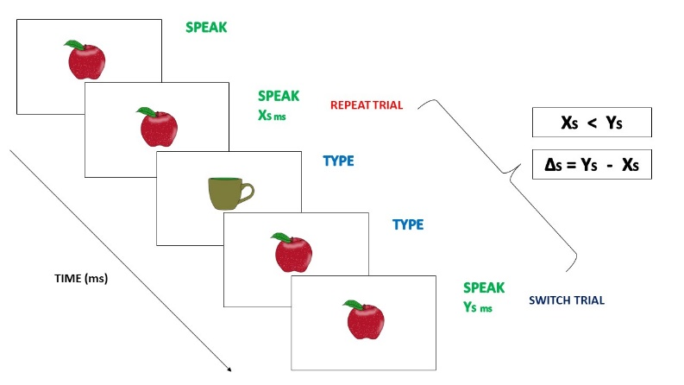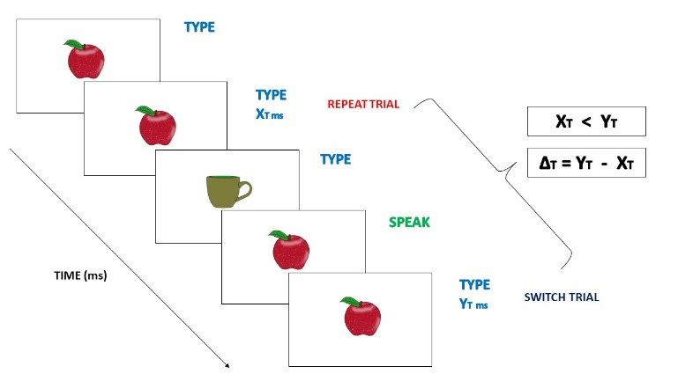
Figure 2. Instances of repeat speak and switch type to speak trials (left) and of repeat type and switch speak to type trials (right). Strong co-activation of phonology in typing and weak co-activation of orthography in speaking (Figure 1) should lead to larger switch costs in switching from speaking to typing: ΔS < ΔT.

REFERENCES:
Bonin, P., Peereman, R., & Fayol, M. (2001). Do Phonological Codes Constrain the Selection of Orthographic Codes in Written Picture Naming? Journal of Memory and Language, 45(4), 688-720.
Costa, A., & Santesteban, M. (2004). Lexical access in bilingual speech production: Evidence from language switching in highly proficient bilinguals and L2 learners. Journal of memory and Language, 50(4), 491-511.
Filippi, R., Karaminis, T., & Thomas, M. S. (2014). Language switching in bilingual production: Empirical data and computational modelling. Bilingualism: Language and Cognition, 17(2), 294-315.
Jevtović, M., Duñabeitia, J. A., & de Bruin, A. (2020). How do bilinguals switch between languages in different interactional contexts? A comparison between voluntary and mandatory language switching. Bilingualism: Language and Cognition, 23(2), 401-413.
Kolinsky, R., Pattamadilok, C., & Morais, J. (2012). The impact of orthographic knowledge on speech processing. Ilha do Desterro A Journal of English Language, Literatures in English and Cultural Studies, (63), 161-186.
Luria, A. R. (1970). Traumatic aphasia: Its syndromes, psychology and treatment (No. 5). Walter de Gruyter.
Macizo, P., Bajo, T., & Paolieri, D. (2012). Language switching and language competition. Second Language Research, 28(2), 131-149.
Meuter, R.F.I. & Allport, A. (1999). Bilingual language-switching in naming: asymmetrical costs of language selection. Journal of Memory and Language, 40, 25-40.
Miceli, G., Benvegnù, B., Capasso, R., & Caramazza, A. (1997). The independence of phonological and orthographic lexical forms: Evidence from aphasia. Cognitive Neuropsychology, 14(1), 35-69.
Pattamadilok, C., Perre, L., Dufau, S., & Ziegler, J. C. (2009). On-line orthographic influences on spoken language in a semantic task. Journal of Cognitive Neuroscience, 21(1), 169-179.
Philipp, A. M., & Koch, I. (2005). Switching of response modalities. The Quarterly Journal of Experimental Psychology Section A, 58(7), 1325-1338.
Philipp, A. M., & Koch, I. (2011). The role of response modalities in cognitive task representations. Advances in Cognitive Psychology, 7, 31.
Philipp, A. M., Weidner, R., Koch, I., & Fink, G. R. (2013). Differential roles of inferior frontal and inferior parietal cortex in task switching: Evidence from stimulus‐categorization switching and response‐modality switching. Human brain mapping, 34(8), 1910-1920.
Pinet, S., Ziegler, J. C., & Alario, F. X. (2016). Typing is writing: Linguistic properties modulate typing execution. Psychonomic bulletin & review, 23, 1898-1906.
Pinet, S., Zielinski, C., Alario, F., & Longcamp, M. (2022). Typing expertise in a large student population. Cognitive Research: Principles and Implications, 7(1), 1-19.
Rastle, K., Mc Cormick, S.F., Bayliss, L. & Davis, C.J. (2011). Orthography influences the perception and production of speech. J Exp Psychol: Learn Mem Cogn, 37(6), 1588-1594.
Scinto, L. F. (1986). Written language and psychological development. Academic Press, Inc.
Wong, W. L., & Maurer, U. (2021). The effects of input and output modalities on language switching between Chinese and English. Bilingualism: Language and Cognition, 24(4), 719-729.

